SMART CAMPUS PARKING & TRAFFIC
INTELLIGENCE SYSTEM
CSA0925-PROGRAMMIN IN JAVA
Report
L. Jayakannan
192525376
E .Lakshmi Narayanan
192524249

GitHub links
https://github.com/Jeyakannan-473/Smart-campus-parking-system---Java
https://github.com/Lakshminarayanan2211/LakshmiNarayanancsa0925

1.PSEUDO CODE
1.1 Application Start and Authentication

BEGIN
LOAD database driver
OPEN AWT login window
READ username and password
IF credentials are valid and active THEN
OPEN dashboard
LOAD parking, occupancy, traffic and alert summaries
ELSE
DISPLAY login error
END IF
END

Algorithmic

Class.forName("com.mysql.cj.jdbc.Driver");
Connection con = DriverManager.getConnection(“jdbc:mysql://localhost:3306/smart_campus_parking","root","password");
String sql = "SELECT * FROM users WHERE username=? AND password=? AND status='ACTIVE'";
PreparedStatement ps = con.prepareStatement(sql);
ps.setString(1, username);
ps.setString(2, password);
ResultSet rs = ps.executeQuery();
if (rs.next()) {
System.out.println("Login successful");
new Dashboard();
} else {
System.out.println("Invalid username or password");}
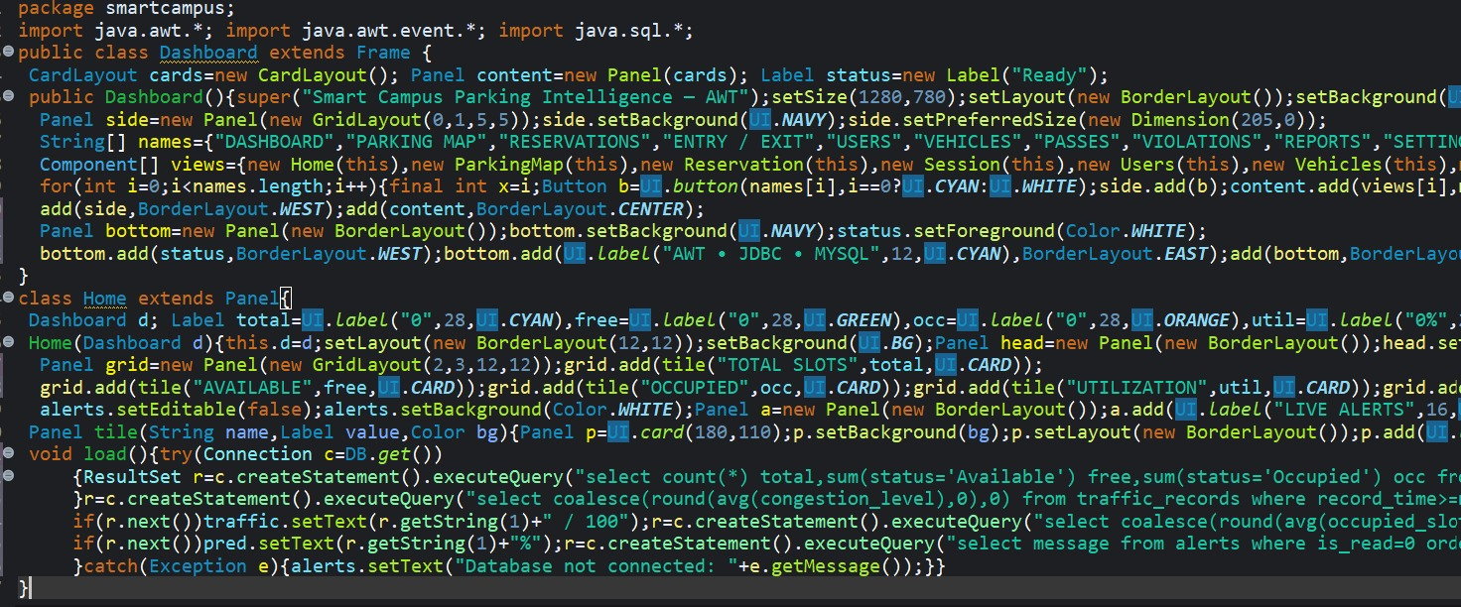
Output:

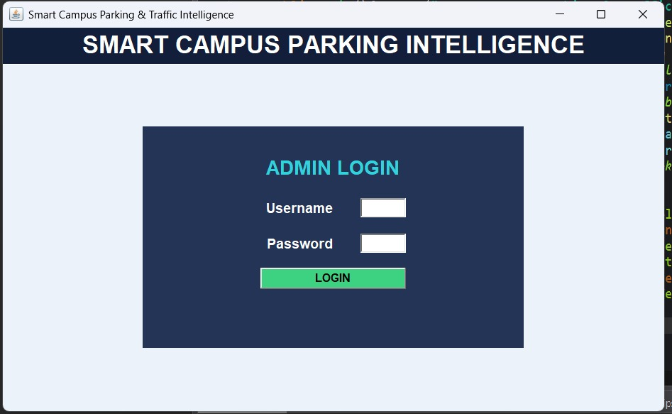

1.2 Smart Slot Recommendation

BEGIN
GET all parking slots
FILTER slots whose status is AVAILABLE
IF no slot exists THEN
DISPLAY no-availability message
STOP
END IF
FOR each available slot
CALCULATE suitability score from current parking information
END FOR
SELECT highest-scoring slot
DISPLAY recommendation
OPTIONALLY STORE recommendation log
END

Algorithmic Logic Code

String sql = "SELECT slot_id, zone_id FROM parking_slots " +
"WHERE status='AVAILABLE'";

Statement st = con.createStatement();
ResultSet rs = st.executeQuery(sql);

int bestSlot = -1;
int bestScore = -1;

while (rs.next()) {
int slotId = rs.getInt("slot_id");
int zoneId = rs.getInt("zone_id");

int score = 100 - (zoneId * 5);

if (score > bestScore) {
bestScore = score;
bestSlot = slotId;
}
}

if (bestSlot == -1) {
System.out.println("No parking slot available");
} else {
System.out.println("Recommended Slot: " + bestSlot);
}
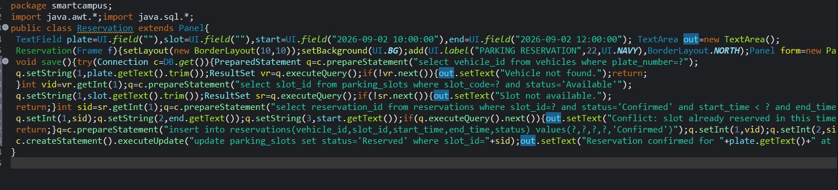

Output;

1.3 Reservation

BEGIN
READ user, vehicle, slot and requested time range
VALIDATE required fields
CHECK slot existence and current status
CHECK overlapping reservations
IF conflict exists THEN
REJECT reservation
ELSE
INSERT reservation
DISPLAY confirmation
END IF
END
Algorithmic Logic Code
String checkSql =
"SELECT reservation_id FROM reservations " +
"WHERE slot_id=? AND start_time < ? AND end_time > ?";

PreparedStatement check = con.prepareStatement(checkSql);

check.setInt(1, slotId);
check.setString(2, endTime);
check.setString(3, startTime);

ResultSet rs = check.executeQuery();

if (rs.next()) {
System.out.println("Reservation conflict");
} else {

String insertSql =
"INSERT INTO reservations " +
"(user_id, vehicle_id, slot_id, start_time, end_time) " +
"VALUES (?, ?, ?, ?, ?)";

PreparedStatement ps = con.prepareStatement(insertSql);

ps.setInt(1, userId);
ps.setInt(2, vehicleId);
ps.setInt(3, slotId);
ps.setString(4, startTime);
ps.setString(5, endTime);

ps.executeUpdate();

System.out.println("Reservation created successfully");
}

Output:
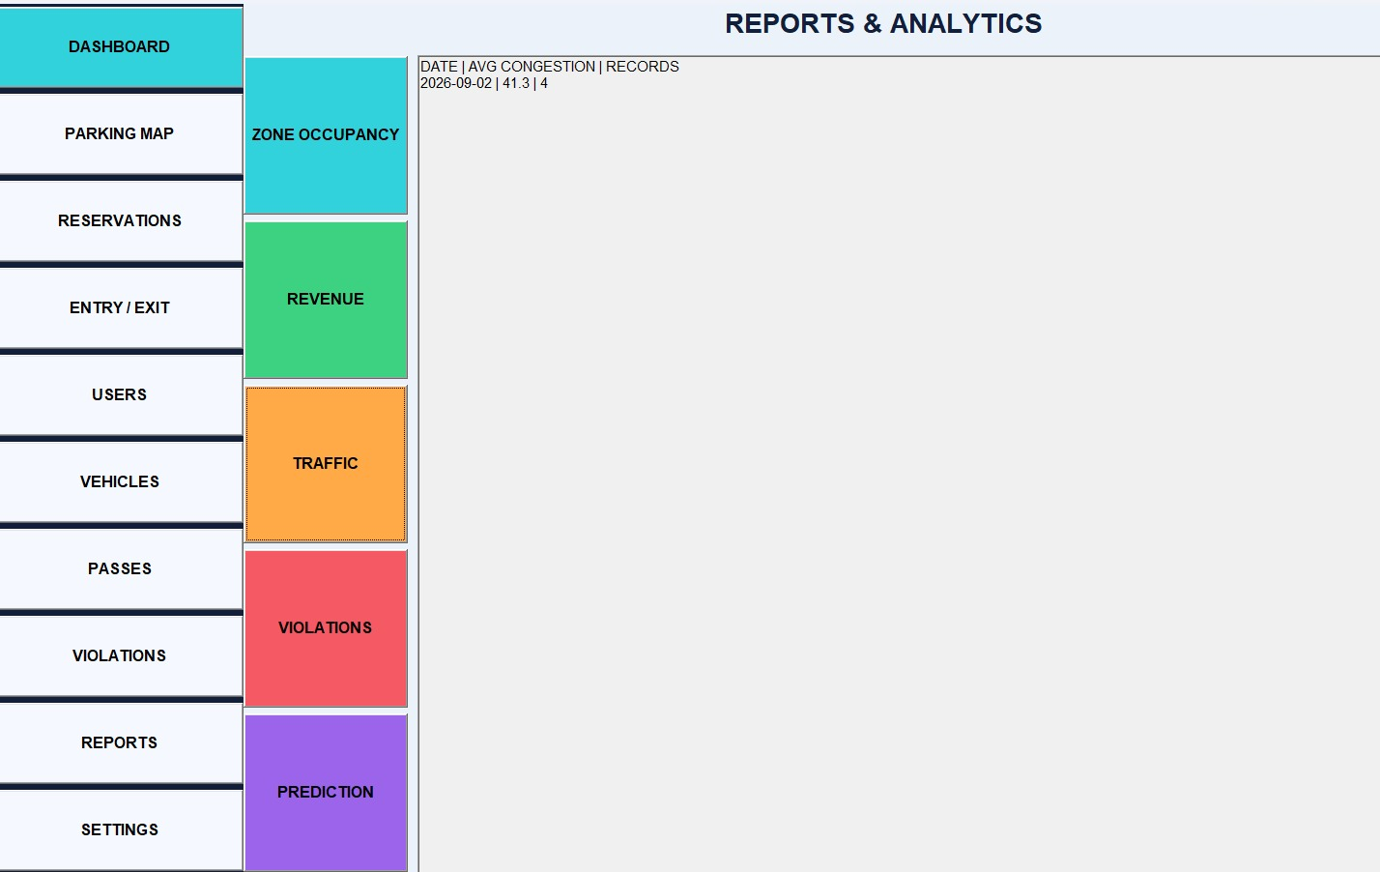

1.4 Vehicle Entry

BEGIN
READ vehicle and selected slot
VALIDATE vehicle registration
CHECK slot availability
IF unavailable THEN DISPLAY error
ELSE
CREATE parking session with entry time
UPDATE slot to OCCUPIED
DISPLAY entry confirmation
END IF
END
Algorithmic Logic Code

String checkSql =
"SELECT status FROM parking_slots WHERE slot_id=?";

PreparedStatement check = con.prepareStatement(checkSql);
check.setInt(1, slotId);

ResultSet rs = check.executeQuery();

if (rs.next() && rs.getString("status").equals("AVAILABLE")) {

String sessionSql =
"INSERT INTO parking_sessions " +
"(vehicle_id, slot_id, entry_time) VALUES (?, ?, NOW())";

PreparedStatement ps = con.prepareStatement(sessionSql);
ps.setInt(1, vehicleId);
ps.setInt(2, slotId);
ps.executeUpdate();

String updateSql =
"UPDATE parking_slots SET status='OCCUPIED' WHERE slot_id=?";

PreparedStatement update = con.prepareStatement(updateSql);
update.setInt(1, slotId);
update.executeUpdate();

System.out.println("Vehicle entry recorded");
} else {
System.out.println("Selected slot is unavailable");
}
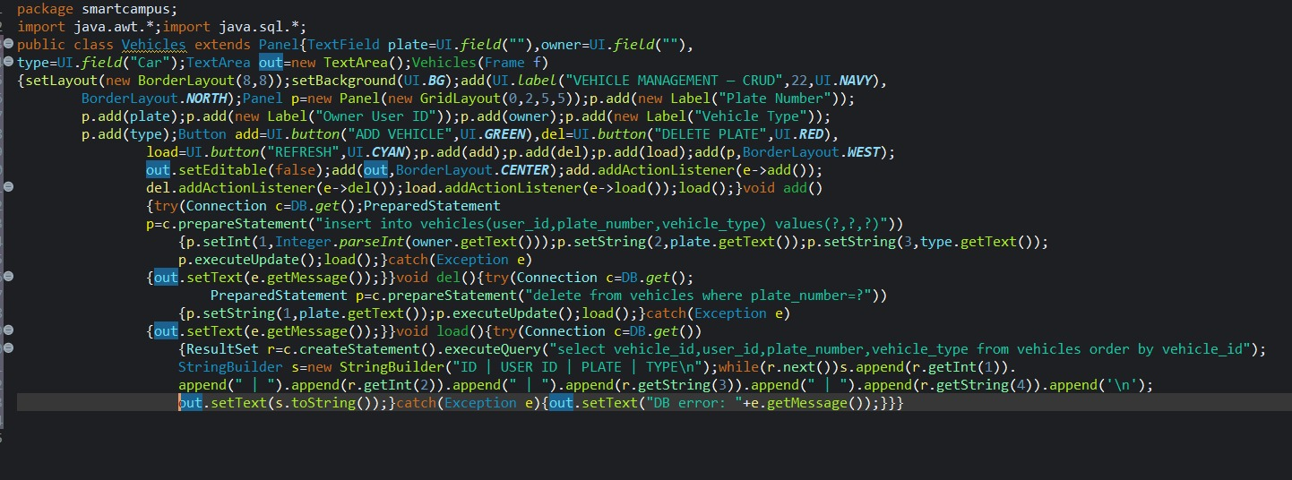

Output :
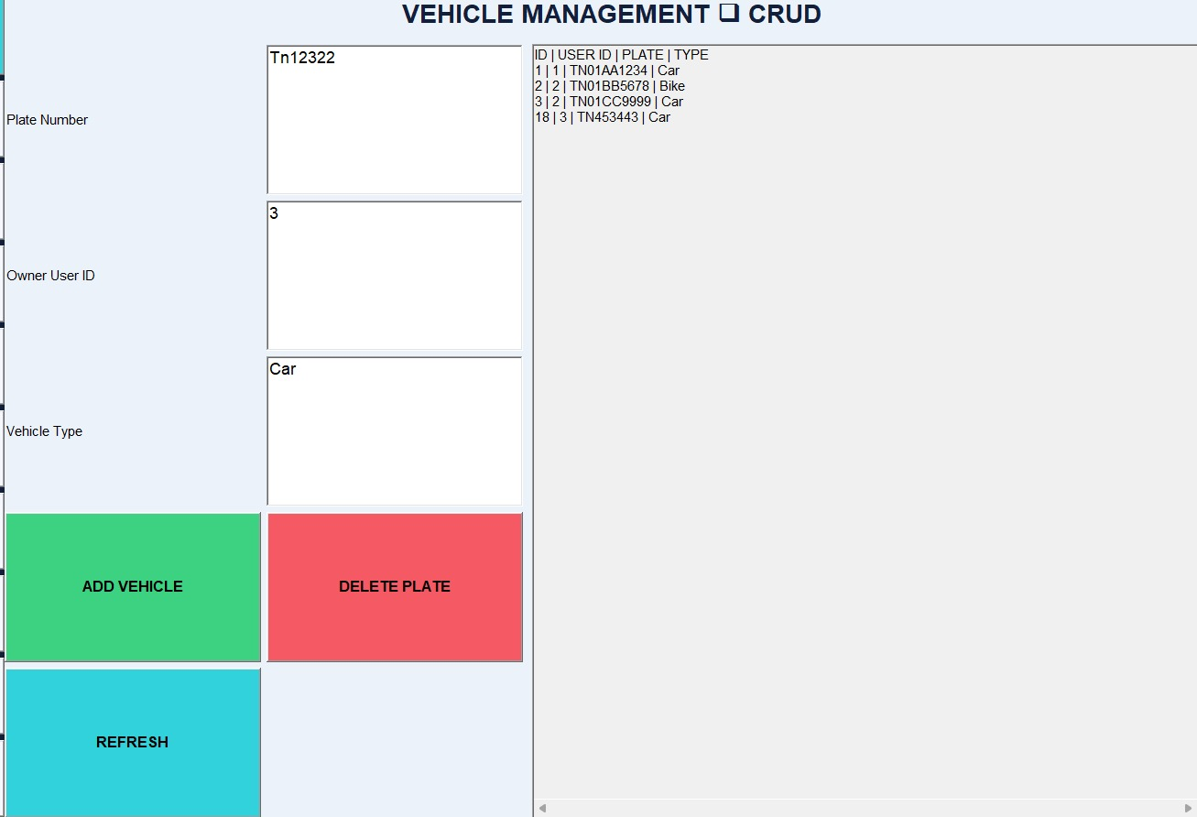

1.5 Vehicle Exit and Fee
BEGIN
FIND active session for vehicle
IF no active session THEN DISPLAY error and STOP
RECORD exit time
CALCULATE duration
CALCULATE parking fee
UPDATE session
CREATE payment record
UPDATE slot to AVAILABLE
DISPLAY exit confirmation and fee
END

Algorithmic Logic Code
String sql =
"SELECT session_id, slot_id, entry_time " +
"FROM parking_sessions " +
"WHERE vehicle_id=? AND exit_time IS NULL";

PreparedStatement ps = con.prepareStatement(sql);
ps.setInt(1, vehicleId);

ResultSet rs = ps.executeQuery();

if (rs.next()) {

int sessionId = rs.getInt("session_id");
int slotId = rs.getInt("slot_id");

String feeSql =
"SELECT TIMESTAMPDIFF(HOUR, entry_time, NOW()) " +
"FROM parking_sessions WHERE session_id=?";

PreparedStatement feePs = con.prepareStatement(feeSql);
feePs.setInt(1, sessionId);

ResultSet feeRs = feePs.executeQuery();

if (feeRs.next()) {
int hours = feeRs.getInt(1);

if (hours < 1)
hours = 1;

double fee = hours * 20.0;

String updateSession =
"UPDATE parking_sessions SET exit_time=NOW(), fee=? " +
"WHERE session_id=?";

PreparedStatement update = con.prepareStatement(updateSession);
update.setDouble(1, fee);
update.setInt(2, sessionId);
update.executeUpdate();

String paymentSql =
"INSERT INTO payments (session_id, amount, payment_status) " +
"VALUES (?, ?, 'PAID')";

PreparedStatement payment = con.prepareStatement(paymentSql);
payment.setInt(1, sessionId);
payment.setDouble(2, fee);
payment.executeUpdate();

String slotSql =
"UPDATE parking_slots SET status='AVAILABLE' WHERE slot_id=?";

PreparedStatement slot = con.prepareStatement(slotSql);
slot.setInt(1, slotId);
slot.executeUpdate();

System.out.println("Exit completed");
System.out.println("Parking Fee: " + fee);
}

} else {
System.out.println("No active parking session found");
}
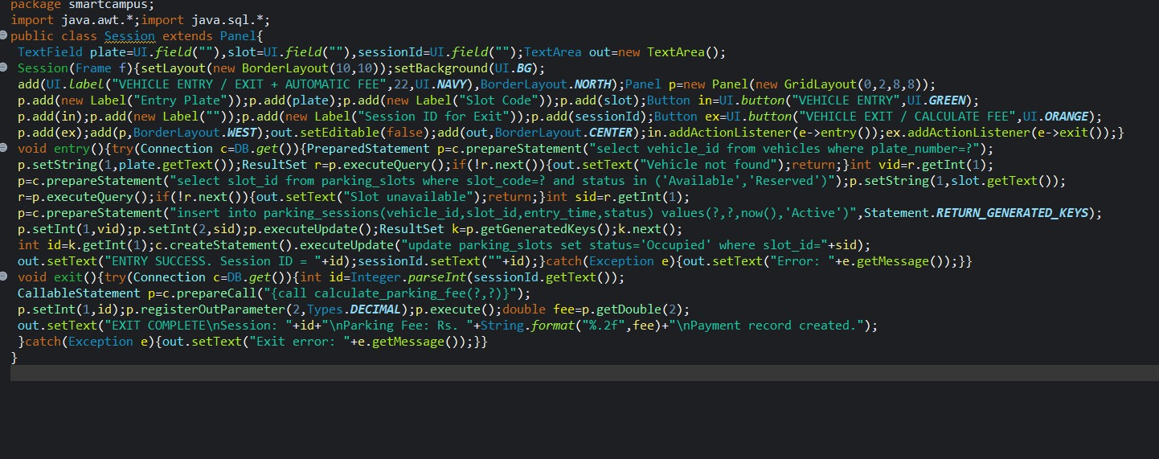

OUTPUT:
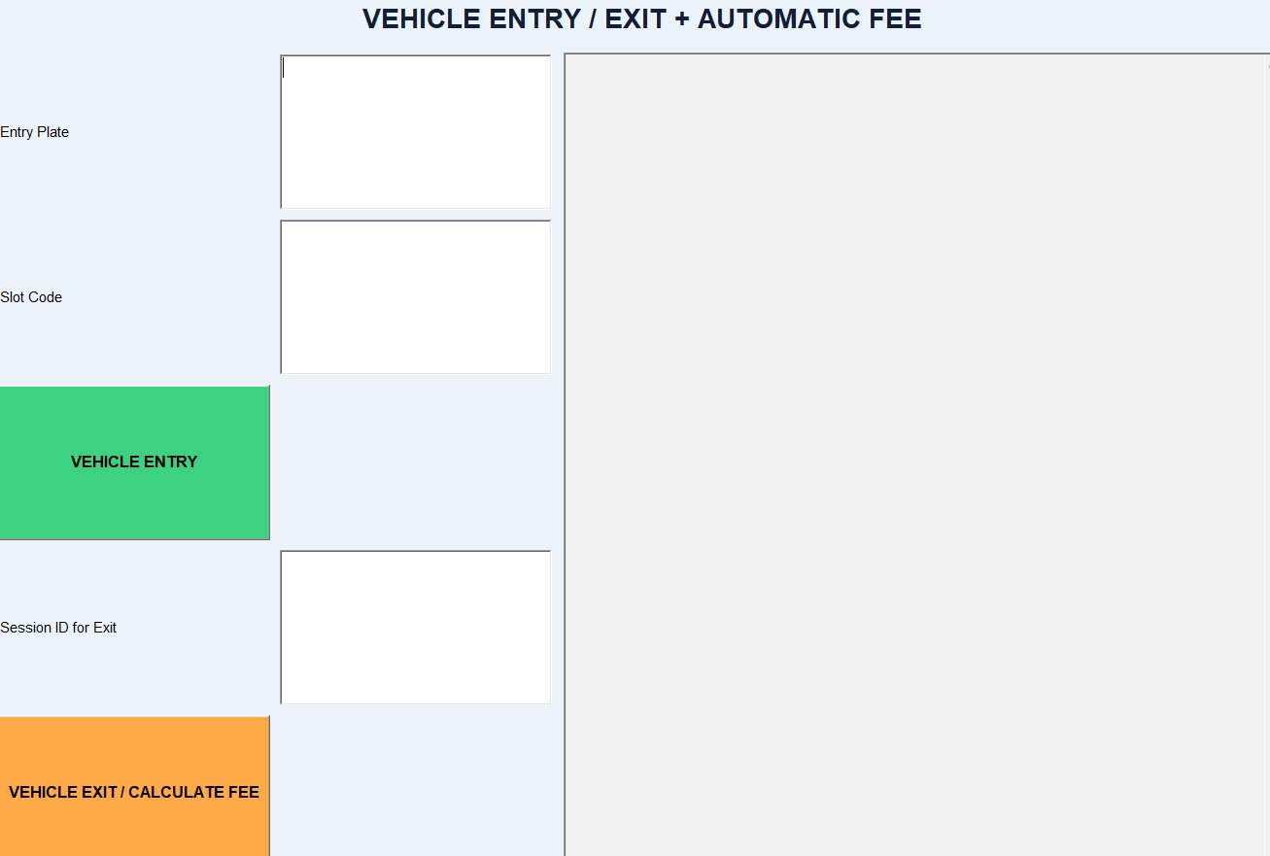

1.6 Digital Pass

BEGIN
READ user and vehicle
VALIDATE vehicle
GENERATE unique pass code
SET issue and expiry time
INSERT pass record
DISPLAY formatted pass
END
Algorithmic Logic Code
String passCode = "PASS" + System.currentTimeMillis();

String sql =
"INSERT INTO parking_passes " +
"(user_id, vehicle_id, pass_code, issue_time, expiry_time) " +
"VALUES (?, ?, ?, NOW(), DATE_ADD(NOW(), INTERVAL 24 HOUR))";

PreparedStatement ps = con.prepareStatement(sql);

ps.setInt(1, userId);
ps.setInt(2, vehicleId);
ps.setString(3, passCode);

ps.executeUpdate();

System.out.println("Digital Parking Pass Generated");
System.out.println("Pass Code: " + passCode);
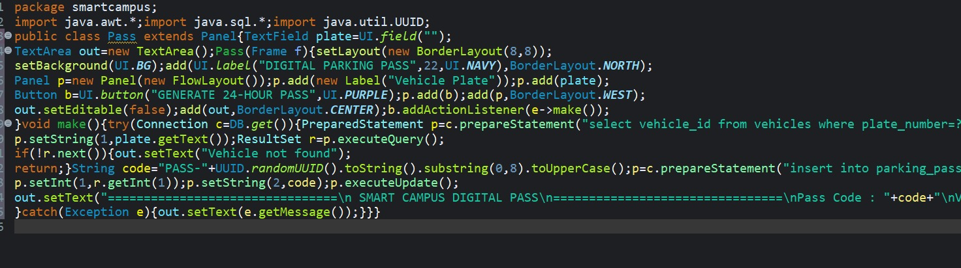
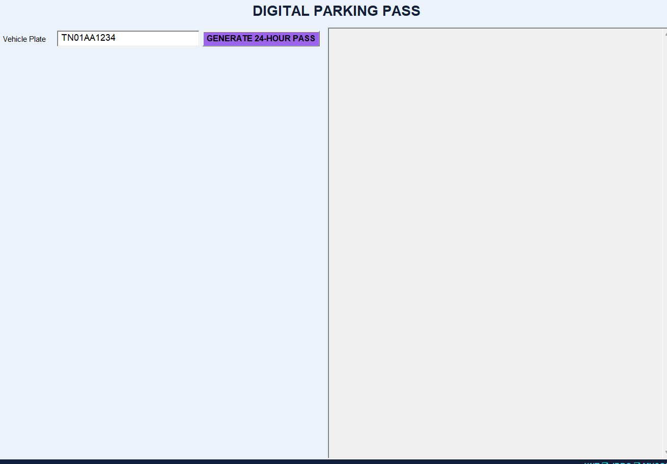

1.7 Violation

BEGIN
READ vehicle, violation type and details
VALIDATE input
DETERMINE fine amount
INSERT violation record
DISPLAY confirmation
END
Algorithmic Logic Code
double fine = 0;

if (violationType.equals("NO_PARKING")) {
fine = 500;
} else if (violationType.equals("WRONG_SLOT")) {
fine = 300;
} else if (violationType.equals("OVERTIME")) {
fine = 200;
}

String sql =
"INSERT INTO violations " +
"(vehicle_id, violation_type, details, fine_amount) " +
"VALUES (?, ?, ?, ?)";

PreparedStatement ps = con.prepareStatement(sql);

ps.setInt(1, vehicleId);
ps.setString(2, violationType);
ps.setString(3, details);
ps.setDouble(4, fine);

ps.executeUpdate();

System.out.println("Violation recorded");
System.out.println("Fine Amount: " + fine);
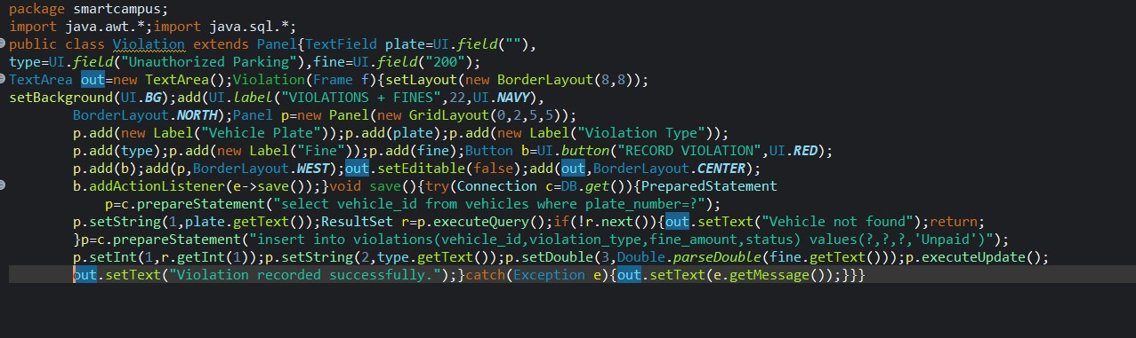
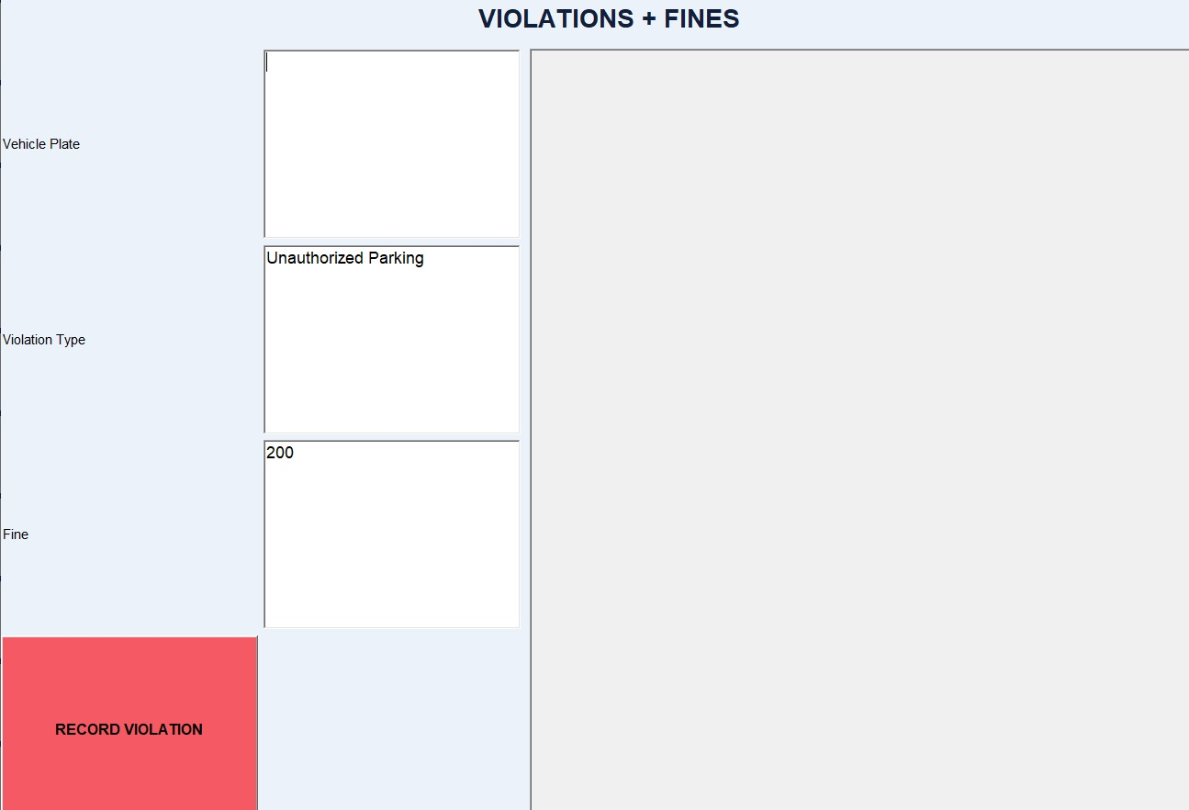

1.8 Reports and Analytics

BEGIN
READ selected report type
IF occupancy THEN calculate zone utilization
ELSE IF revenue THEN sum paid amounts
ELSE IF traffic THEN calculate grouped congestion summary
ELSE IF violations THEN group counts and fines
ELSE IF prediction baseline THEN calculate recent historical occupancy average
DISPLAY result
END
Algorithmic Logic Code
if (reportType.equals("occupancy")) {

String sql =
"SELECT zone_id, COUNT(*) AS total_slots, " +
"SUM(status='OCCUPIED') AS occupied " +
"FROM parking_slots GROUP BY zone_id";

Statement st = con.createStatement();
ResultSet rs = st.executeQuery(sql);

while (rs.next()) {
int zone = rs.getInt("zone_id");
int total = rs.getInt("total_slots");
int occupied = rs.getInt("occupied");

double utilization = (occupied * 100.0) / total;

System.out.println(
"Zone: " + zone +
" Utilization: " + utilization + "%"
);
}

} else if (reportType.equals("revenue")) {

String sql =
"SELECT SUM(amount) AS total_revenue " +
"FROM payments WHERE payment_status='PAID'";

Statement st = con.createStatement();
ResultSet rs = st.executeQuery(sql);
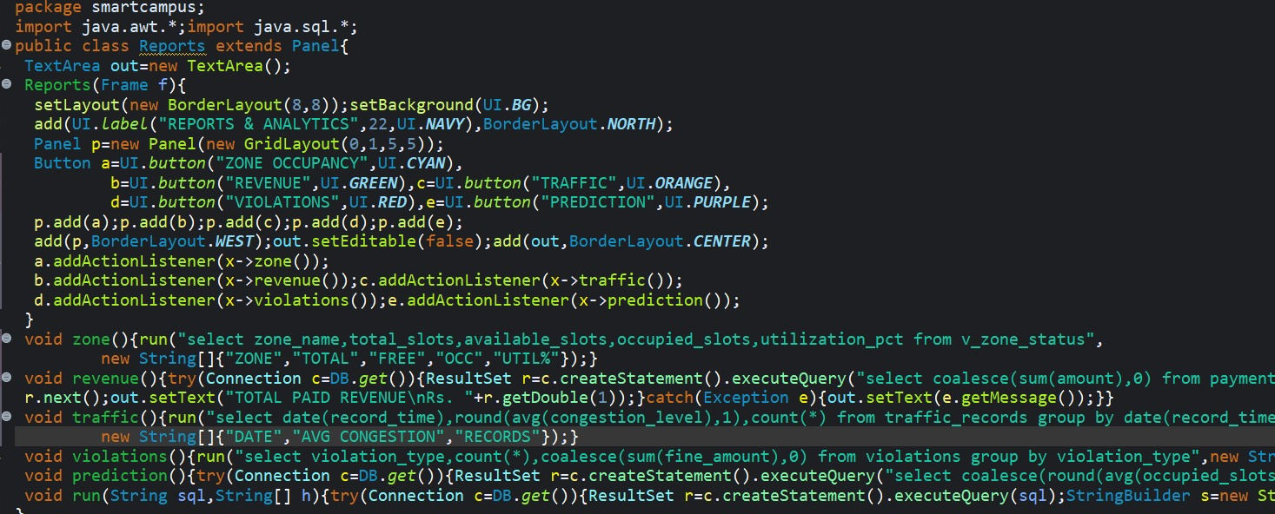
Ouput :
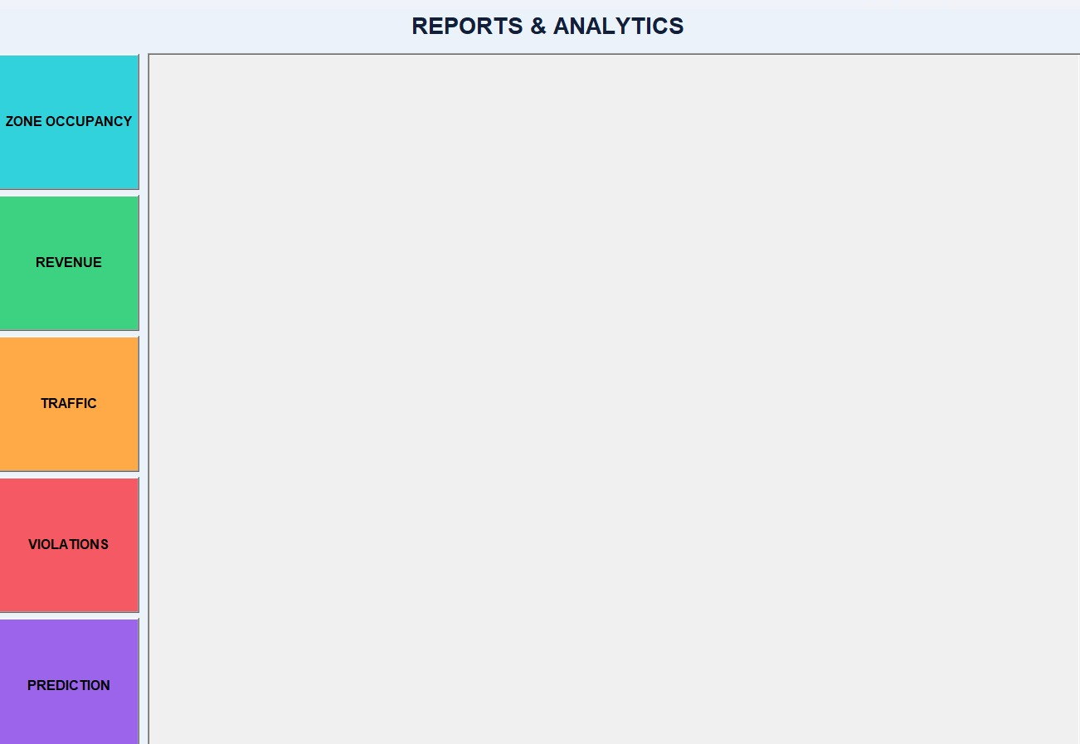

UML / System Design Diagrams

2.1 Use Case Diagram
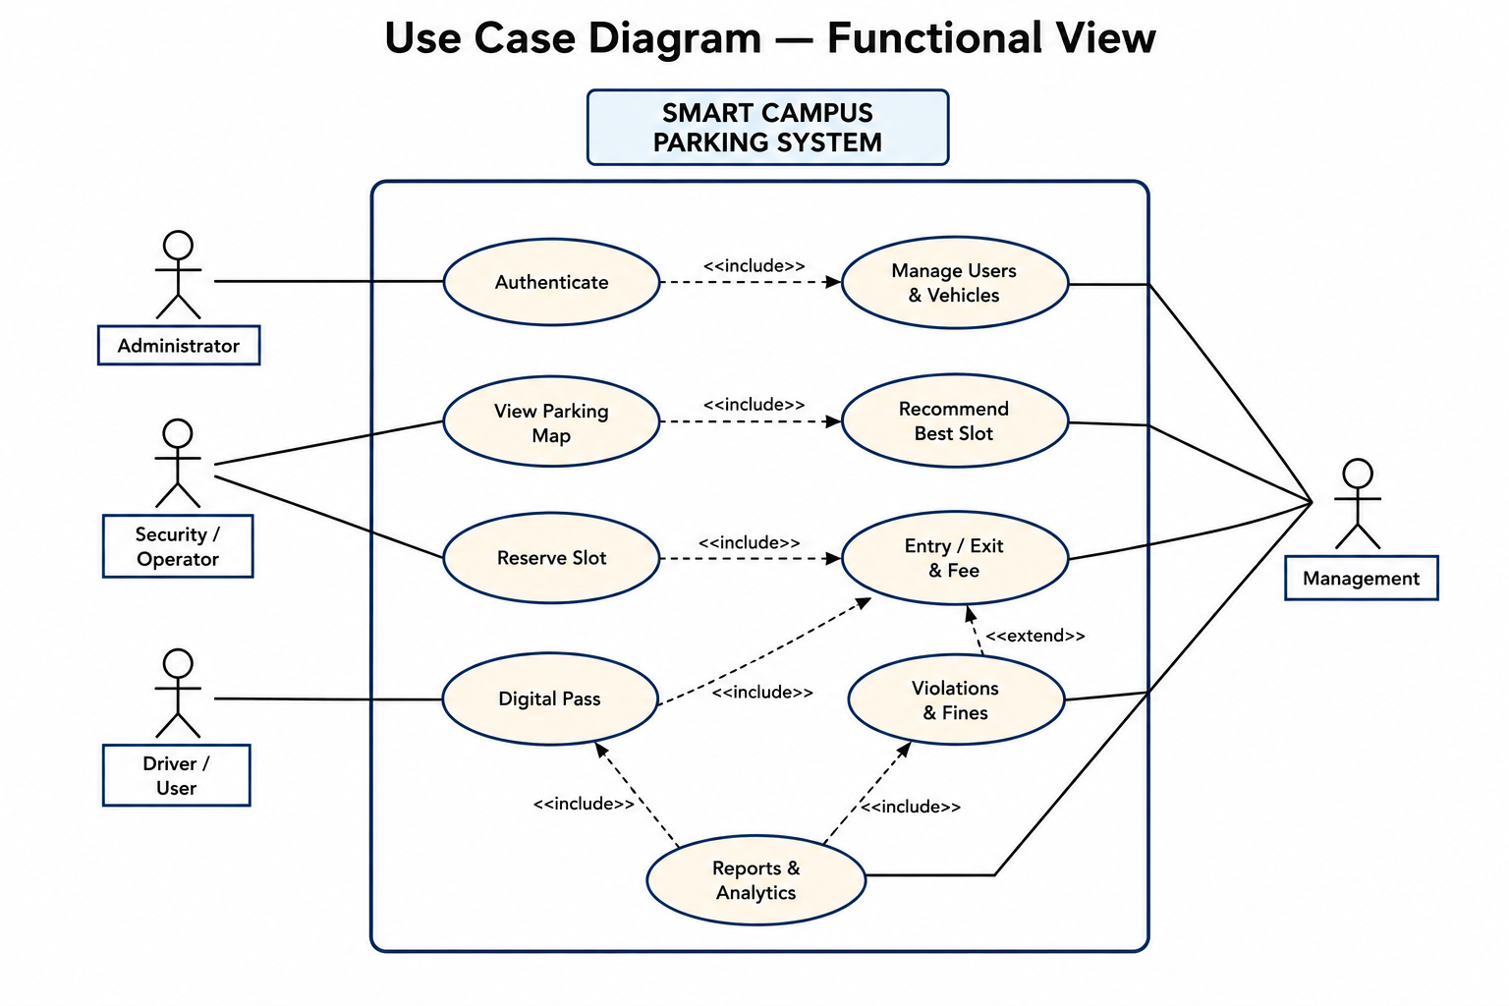

The use case diagram identifies the main actors and system interactions: authentication, parking visualization, slot recommendation, reservation, vehicle movement, digital passes, violations and management reports.

2.2 Activity Diagram
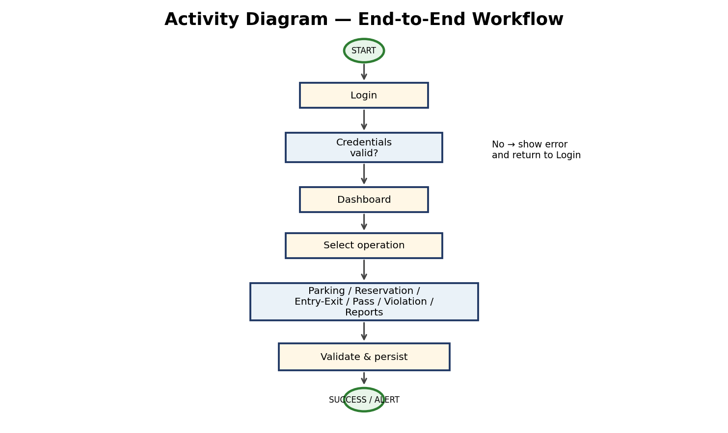
The activity diagram models the normal flow from login to dashboard, operation selection, validation, database persistence and success/alert output.

2.3 Class Diagram
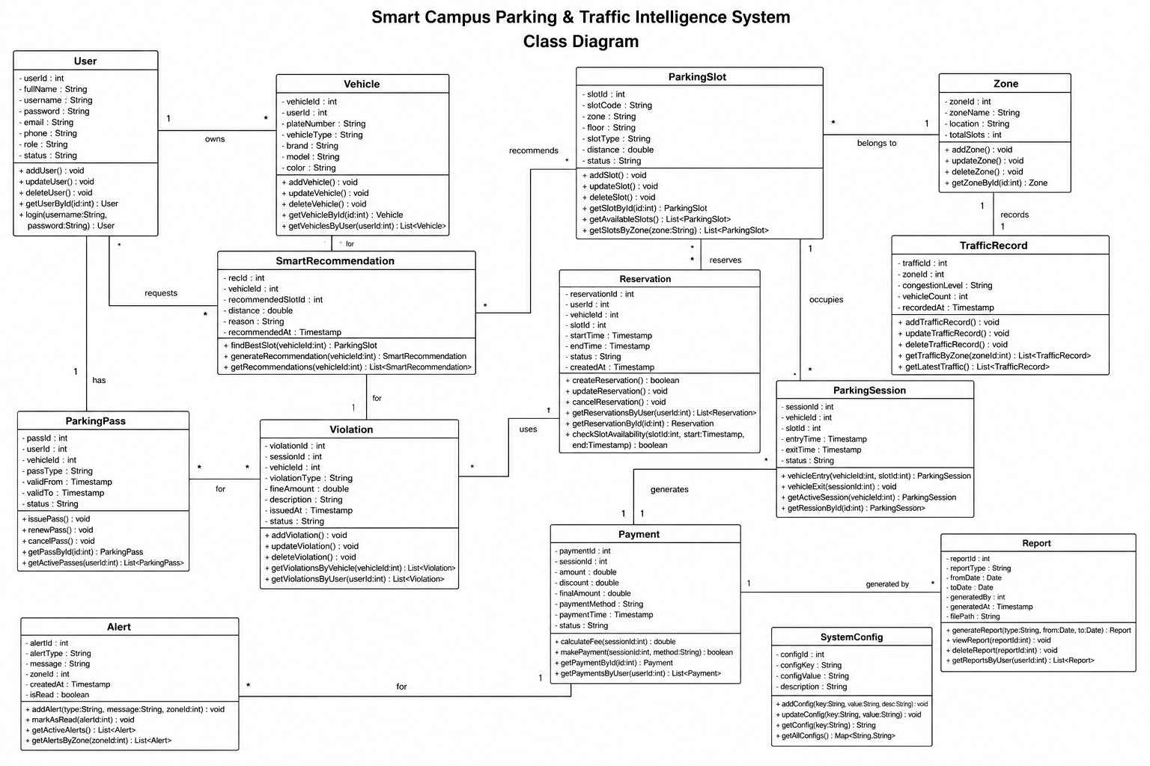
The class diagram captures the core domain responsibilities and database-facing structure. UI/controller classes can be treated as additional implementation classes around these core concepts.

14. Individual Contribution Write-up
Jeyakannan L
192525376

During the development of the Smart Campus Parking & Traffic Intelligence System, my contribution focused on understanding the assigned parking-management problem and converting the requirements into a structured Java AWT and MySQL solution. I participated in planning the system modules and in maintaining the requirement that the graphical interface use AWT rather than Swing. I considered how the user interface, application logic and database should interact so that each operation produces a consistent result.
I contributed to the implementation of the AWT interface and event-driven operations. This involved working with components such as Frame, Panel, Button, Label, TextField, Choice, TextArea and graphical drawing facilities. I worked on the flow of user actions, input validation and the presentation of successful operations or error messages. I also contributed to parking functions such as slot availability, reservation handling, vehicle entry and exit, parking fee calculation, digital pass generation and violation recording.

E. Lakshmi Narayanan
192524249

I contributed to JDBC connectivity and SQL operations. I worked with database queries and parameterized operations and considered the appropriate use of Statement, PreparedStatement and CallableStatement. I also checked that transactions initiated from the AWT application were reflected in MySQL Workbench. This helped connect the frontend actions with persistent records such as reservations, parking sessions, payments and violations.
Testing and debugging were another part of my contribution. I checked normal and invalid inputs, reservation conflicts, unavailable parking slots, missing active sessions, database connectivity and report output. When errors occurred, I traced the event-handling logic and database operations to identify the source of the problem and verify the corrected behavior.
I also contributed to the documentation and presentation of the project by preparing pseudocode, system descriptions, UML diagrams, test cases and screenshot evidence. I supported the organization of the source files and database script for GitHub so that the project can be reproduced by another team member. Through this work, I gained practical experience in Java AWT GUI development, event handling, JDBC, MySQL, debugging, testing, documentation and collaborative software development.

